Random Forest Algorithm in Machine Learning

What is the Random Forest Algorithm?
Random Forest algorithm is a powerful tree learning technique in Machine Learning. It works by creating a number of Decision Trees during the training phase. Each tree is constructed using a random subset of the data set to measure a random subset of features in each partition. This randomness introduces variability among individual trees, reducing the risk of overfitting and improving overall prediction performance.
In prediction, the algorithm aggregates the results of all trees, either by voting (for classification tasks) or by averaging (for regression tasks) This collaborative decision-making process, supported by multiple trees with their insights, provides an example stable and precise results. Random forests are widely used for classification and regression functions, which are known for their ability to handle complex data, reduce overfitting, and provide reliable forecasts in different environments.
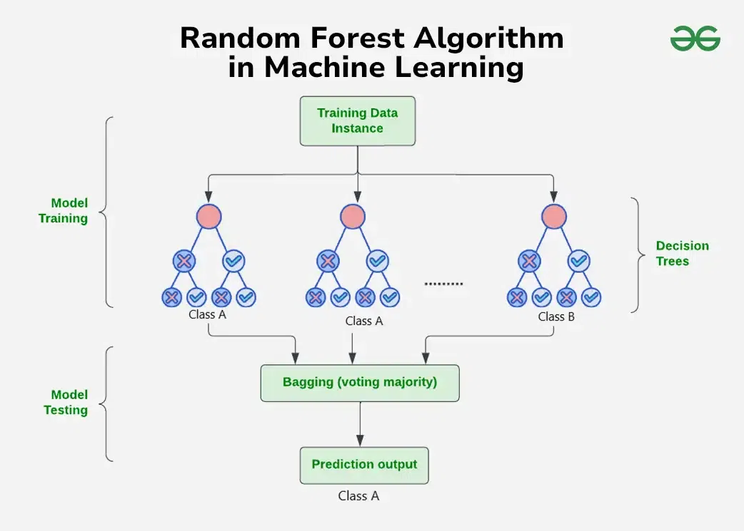

How Does Random Forest Work?
The random Forest algorithm works in several steps which are discussed below–>
- Ensemble of Decision Trees: Random Forest leverages the power of ensemble learning by constructing an army of Decision Trees. These trees are like individual experts, each specializing in a particular aspect of the data. Importantly, they operate independently, minimizing the risk of the model being overly influenced by the nuances of a single tree.
- Random Feature Selection: To ensure that each decision tree in the ensemble brings a unique perspective, Random Forest employs random feature selection. During the training of each tree, a random subset of features is chosen. This randomness ensures that each tree focuses on different aspects of the data, fostering a diverse set of predictors within the ensemble.
- Bootstrap Aggregating or Bagging: The technique of bagging is a cornerstone of Random Forest’s training strategy which involves creating multiple bootstrap samples from the original dataset, allowing instances to be sampled with replacement. This results in different subsets of data for each decision tree, introducing variability in the training process and making the model more robust.
- Decision Making and Voting: When it comes to making predictions, each decision tree in the Random Forest casts its vote. For classification tasks, the final prediction is determined by the mode (most frequent prediction) across all the trees. In regression tasks, the average of the individual tree predictions is taken. This internal voting mechanism ensures a balanced and collective decision-making process.

Key Features of Random Forest
Some of the Key Features of Random Forest are discussed below–>
- High Predictive Accuracy: Imagine Random Forest as a team of decision-making wizards. Each wizard (decision tree) looks at a part of the problem, and together, they weave their insights into a powerful prediction tapestry. This teamwork often results in a more accurate model than what a single wizard could achieve.
- Resistance to Overfitting: Random Forest is like a cool-headed mentor guiding its apprentices (decision trees). Instead of letting each apprentice memorize every detail of their training, it encourages a more well-rounded understanding. This approach helps prevent getting too caught up with the training data which makes the model less prone to overfitting.
- Large Datasets Handling: Dealing with a mountain of data? Random Forest tackles it like a seasoned explorer with a team of helpers (decision trees). Each helper takes on a part of the dataset, ensuring that the expedition is not only thorough but also surprisingly quick.
- Variable Importance Assessment: Think of Random Forest as a detective at a crime scene, figuring out which clues (features) matter the most. It assesses the importance of each clue in solving the case, helping you focus on the key elements that drive predictions.
- Built-in Cross-Validation: Random Forest is like having a personal coach that keeps you in check. As it trains each decision tree, it also sets aside a secret group of cases (out-of-bag) for testing. This built-in validation ensures your model doesn’t just ace the training but also performs well on new challenges.
- Handling Missing Values: Life is full of uncertainties, just like datasets with missing values. Random Forest is the friend who adapts to the situation, making predictions using the information available. It doesn’t get flustered by missing pieces; instead, it focuses on what it can confidently tell us.
- Parallelization for Speed: Random Forest is your time-saving buddy. Picture each decision tree as a worker tackling a piece of a puzzle simultaneously. This parallel approach taps into the power of modern tech, making the whole process faster and more efficient for handling large-scale projects.

Random Forest vs. Other Machine Learning Algorithms
Some of the key-differences are discussed below.
Feature | Random Forest | Other ML Algorithms
Ensemble Approach | Utilizes an ensemble of decision trees, combining their outputs for predictions, fostering robustness and accuracy. | Typically relies on a single model (e.g., linear regression, support vector machine) without the ensemble approach, potentially leading to less resilience against noise.
Overfitting Resistance | Resistant to overfitting due to the aggregation of diverse decision trees, preventing memorization of training data. | Some algorithms may be prone to overfitting, especially when dealing with complex datasets, as they may excessively adapt to training noise.
Handling of Missing Data | Exhibits resilience in handling missing values by leveraging available features for predictions, contributing to practicality in real-world scenarios. | Other algorithms may require imputation or elimination of missing data, potentially impacting model training and performance.
Variable Importance | Provides a built-in mechanism for assessing variable importance, aiding in feature selection and interpretation of influential factors. | Many algorithms may lack an explicit feature importance assessment, making it challenging to identify crucial variables for predictions.
Parallelization Potential | Capitalizes on parallelization, enabling the simultaneous training of decision trees, resulting in faster computation for large datasets. | Some algorithms may have limited parallelization capabilities, potentially leading to longer training times for extensive datasets.

Preparing Data for Random Forest Modeling
For Random Forest modeling, some key-steps of data preparation are discussed below:
- Handling Missing Values: Begin by addressing any missing values in the dataset. Techniques like imputation or removal of instances with missing values ensure a complete and reliable input for Random Forest.
- Encoding Categorical Variables: Random Forest requires numerical inputs, so categorical variables need to be encoded. Techniques like one-hot encoding or label encoding transform categorical features into a format suitable for the algorithm.
- Scaling and Normalization: While Random Forest is not sensitive to feature scaling, normalizing numerical features can still contribute to a more efficient training process and improved convergence.
- Feature Selection: Assess the importance of features within the dataset. Random Forest inherently provides a feature importance score, aiding in the selection of relevant features for model training.
- Addressing Imbalanced Data: If dealing with imbalanced classes, implement techniques like adjusting class weights or employing resampling methods to ensure a balanced representation during training.

Difference Between Decision Tree and Random Forest

Random forest is a collection of decision trees; still, there are a lot of differences in their behavior.
Decision trees | Random Forest
1. Decision trees normally suffer from the problem of overfitting if it’s allowed to grow without any control. | 1. Random forests are created from subsets of data, and the final output is based on average or majority ranking; hence the problem of overfitting is taken care of.
2. A single decision tree is faster in computation. | 2. It is comparatively slower.
3. When a data set with features is taken as input by a decision tree, it will formulate some rules to make predictions. | 3. Random forest randomly selects observations, builds a decision tree, and takes the average result. It doesn’t use any set of formulas.
Thus random forests are much more successful than decision trees only if the trees are diverse and acceptable.

Important Hyperparameters in Random Forest

Hyperparameters are used in random forests to either enhance the performance and predictive power of models or to make the model faster.

Increase the Predictive Power

n_estimators: Number of trees the algorithm builds before averaging the predictions.

max_features: Maximum number of features random forest considers splitting a node.

mini_sample_leaf: Determines the minimum number of leaves required to split an internal node.

criterion: How to split the node in each tree? (Entropy/Gini impurity/Log Loss)

max_leaf_nodes: Maximum leaf nodes in each tree

Increase the Speed

n_jobs: it tells the engine how many processors it is allowed to use. If the value is 1, it can use only one processor, but if the value is -1, there is no limit.

random_state: controls randomness of the sample. The model will always produce the same results if it has a definite value of random state and has been given the same hyperparameters and training data.

oob_score: OOB means out of the bag. It is a random forest cross-validation method. In this, one-third of the sample is not used to train the data; instead used to evaluate its performance. These samples are called out-of-bag samples.

Applications of Random Forest
There are mainly four sectors where Random forest mostly used:
- Banking: Banking sector mostly uses this algorithm for the identification of loan risk.
- Medicine: With the help of this algorithm, disease trends and risks of the disease can be identified.
- Land Use: We can identify the areas of similar land use by this algorithm.
- Marketing: Marketing trends can be identified using this algorithm.

Advantages of Random Forest
- Random Forest is capable of performing both Classification and Regression tasks.
- It is capable of handling large datasets with high dimensionality.
- It enhances the accuracy of the model and prevents the overfitting issue.

Disadvantages of Random Forest
- Although random forest can be used for both classification and regression tasks, it is not more suitable for Regression tasks.

What is a random forest? Why is it good?
Random forests are an ensemble learning technique that builds off of decision trees. Random forests involve creating multiple decision trees using bootstrapped datasets of the original data and randomly selecting a subset of variables at each step of the decision tree. The model then selects the mode of all of the predictions of each decision tree. By relying on a “majority wins” model, it reduces the risk of error from an individual tree.
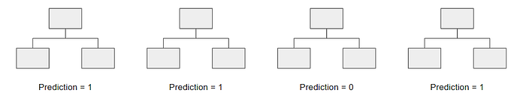
For example, if we created one decision tree, the third one, it would predict 0. But if we relied on the mode of all 4 decision trees, the predicted value would be 1. This is the power of random forests.
Random forests offer several other benefits including strong performance, can model non-linear boundaries, no cross-validation needed, and gives feature importance.

What is Ensemble learning?
Ensemble learning is a technique that is used to create multiple Machine Learning models, which are then combined to produce more accurate results. A general Machine Learning model is built by using the entire training data set. However, in Ensemble Learning the training data set is split into multiple subsets, wherein each subset is used to build a separate model. After the models are trained, they are then combined to predict an outcome in such a way that the variance in the output is reduced.
There are many reasons for a model to be different. Few reasons are:
- Different Population
- Different Hypothesis
- Different modelling techniques

When working with the model’s training and testing data, we will experience an error. This error might be bias, variance, and irreducible error. Now the model should always have a balance between bias and variance, which we call a bias-variance trade-off. This ensemble learning is a way to perform this trade-off. There are many ensemble techniques available but when aggregating multiple models there are two general methods:
Bagging, a native method: take the training set and generate new training sets off of it.
Boosting, a more elegant method: similar to bagging, boosting is used to optimize the best weighting scheme for a training set.

